Exapense Details Demo

Src 🡺 create a folder Components

New File ExpenseItem.jsx

function ExpenseItem() {

return <h2>Expense item!</h2>;

}

export default ExpenseItem;

app.js

<div>

<ExpenseItem />

</div>

Output:

It will display

Expense Item!

Then Modify with the below code(complex code than the previous code)

import React, { Component } from 'react';

function ExpenseItem() {

    return (

      <div>

        <div>March 28th 2021</div>

        <div>

          <h2>Car Insurance</h2>

          <div>$294.67</div>

        </div>

      </div>

    );

  }

  export default ExpenseItem;

App.JS

import logo from './logo.svg';

import './App.css';

import ExpenseItem from './Components/ExpenseItem';

function App() {

  return (

    <div className="App">

      <ExpenseItem />

    </div>

  );

}

export default App;

Output

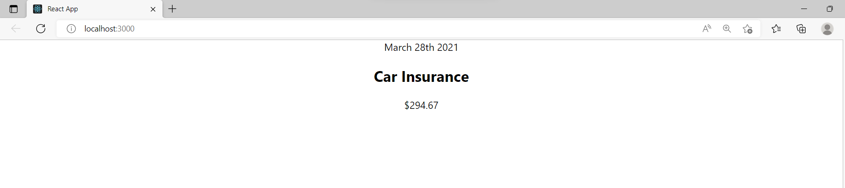

App.js

Remove className =”App”

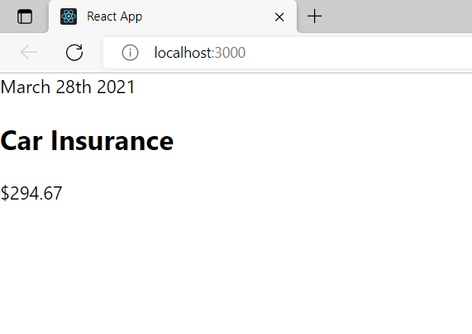

Adding Basic Css Stying to the Component

NewFile ExpenseItem.css

.expense-item {

    display: flex;

    justify-content: space-between;

    align-items: center;

    box-shadow: 0 2px 8px rgba(0, 0, 0, 0.25);

    padding: 0.5rem;

    margin: 1rem 0;

    border-radius: 12px;

    background-color: #4b4b4b;

  }

  .expense-item__description {

    display: flex;

    flex-direction: column;

    gap: 1rem;

    align-items: flex-end;

    flex-flow: column-reverse;

    justify-content: flex-start;

    flex: 1;

  }

  .expense-item h2 {

    color: #3a3a3a;

    font-size: 1rem;

    flex: 1;

    margin: 0 1rem;

    color: white;

  }

  .expense-item__price {

    font-size: 1rem;

    font-weight: bold;

    color: white;

    background-color: #40005d;

    border: 1px solid white;

    padding: 0.5rem;

    border-radius: 12px;

  }

  @media (min-width: 580px) {

    .expense-item__description {

      flex-direction: row;

      align-items: center;

      justify-content: flex-start;

      flex: 1;

    }

    .expense-item__description h2 {

      font-size: 1.25rem;

    }

    .expense-item__price {

      font-size: 1.25rem;

      padding: 0.5rem 1.5rem;

    }

  }

ExpenseItem.jsx

import './ExpenseItem.css';

function ExpenseItem() {

    return (

        <div className="expense-item">

        <div>March 28th 2021</div>

        <div className="expense-item__description">

          <h2>Car Insurance</h2>

          <div className="expense-item__price">$294.67</div>

        </div>

      </div>

    );

  }

  export default ExpenseItem;

Output:

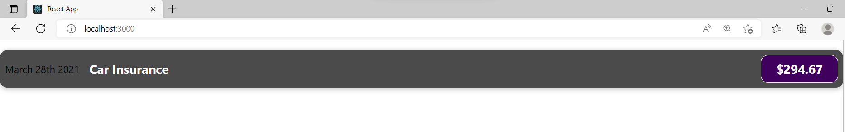

In the above demo everything is a hardcoded value but it not recommended in realworld

In the below example we will declare variable or object to set the values and display the ouput

ExpenseItem.js

import './ExpenseItem.css';

function ExpenseItem() {

  const expenseDate = new Date(2021, 2, 28);

  const expenseTitle = 'Car Insurance';

  const expenseAmount = 294.67;

  return (

    <div className='expense-item'>

      <div>{expenseDate.toISOString()}</div>

      <div className='expense-item__description'>

        <h2>{expenseTitle}</h2>

        <div className='expense-item__price'>${expenseAmount}</div>

      </div>

    </div>

  );

}

export default ExpenseItem;

we will get the same output as above code

Pass Data via Prop to the ExpendeItem Element from App.js (Parent Component)

ExpenseItem.js

import './ExpenseItem.css';

function ExpenseItem(props) {

    return (

      <div className='expense-item'>

        <div>{props.date.toISOString()}</div>

        <div className='expense-item__description'>

          <h2>{props.title}</h2>

          <div className='expense-item__price'>${props.amount}</div>

        </div>

      </div>

    );

  }

export default ExpenseItem;

app.js

import logo from './logo.svg';

import './App.css';

import ExpenseItem from './Components/ExpenseItem';

function App() {

  const expenses = [

    {

      id: 'e1',

      title: 'Toilet Paper',

      amount: 94.12,

      date: new Date(2020, 7, 14),

    },

    { id: 'e2', title: 'New TV', amount: 799.49, date: new Date(2021, 2, 12) },

    {

      id: 'e3',

      title: 'Car Insurance',

      amount: 294.67,

      date: new Date(2021, 2, 28),

    },

    {

      id: 'e4',

      title: 'New Desk (Wooden)',

      amount: 450,

      date: new Date(2021, 5, 12),

    },

  ];

  return (

    <div>

      <h2>Let's get started!</h2>

      <ExpenseItem

        title={expenses[0].title}

        amount={expenses[0].amount}

        date={expenses[0].date}

      ></ExpenseItem>

      <ExpenseItem

        title={expenses[1].title}

        amount={expenses[1].amount}

        date={expenses[1].date}

      ></ExpenseItem>

      <ExpenseItem

        title={expenses[2].title}

        amount={expenses[2].amount}

        date={expenses[2].date}

      ></ExpenseItem>

      <ExpenseItem

        title={expenses[3].title}

        amount={expenses[3].amount}

        date={expenses[3].date}

      />

    </div>

  );

}

export default App;

output

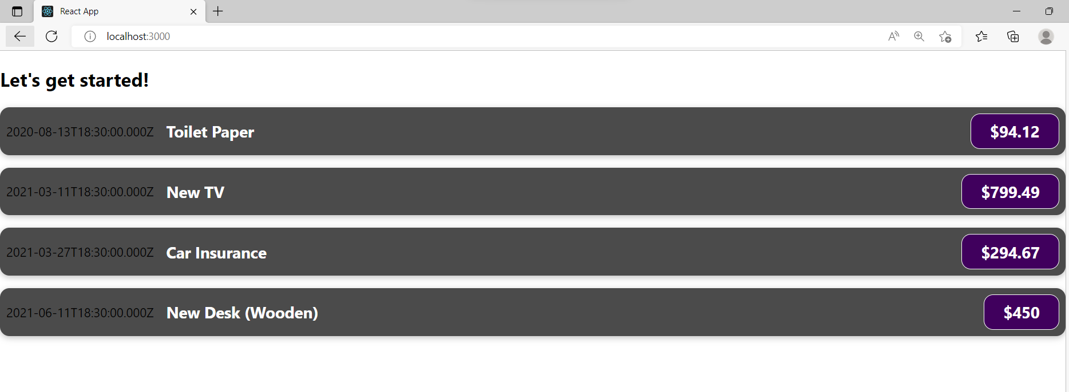

Add normal Javascript Logic to display the Date in Different Format (below)

ExpenseIte.js

import './ExpenseItem.css';

function ExpenseItem(props)

     {

        const month = props.date.toLocaleString('en-US', { month: 'long' });

        const day = props.date.toLocaleString('en-US', { day: '2-digit' });

        const year = props.date.getFullYear();

    return (

        <div className='expense-item'>

        <div>

          <div>{month}</div>

          <div>{year}</div>

          <div>{day}</div>

        </div>

        <div>{props.date.toISOString()}</div>

        <div className='expense-item__description'>

          <h2>{props.title}</h2>

          <div className='expense-item__price'>${props.amount}</div>

        </div>

      </div>

    );

  }

export default ExpenseItem;

output

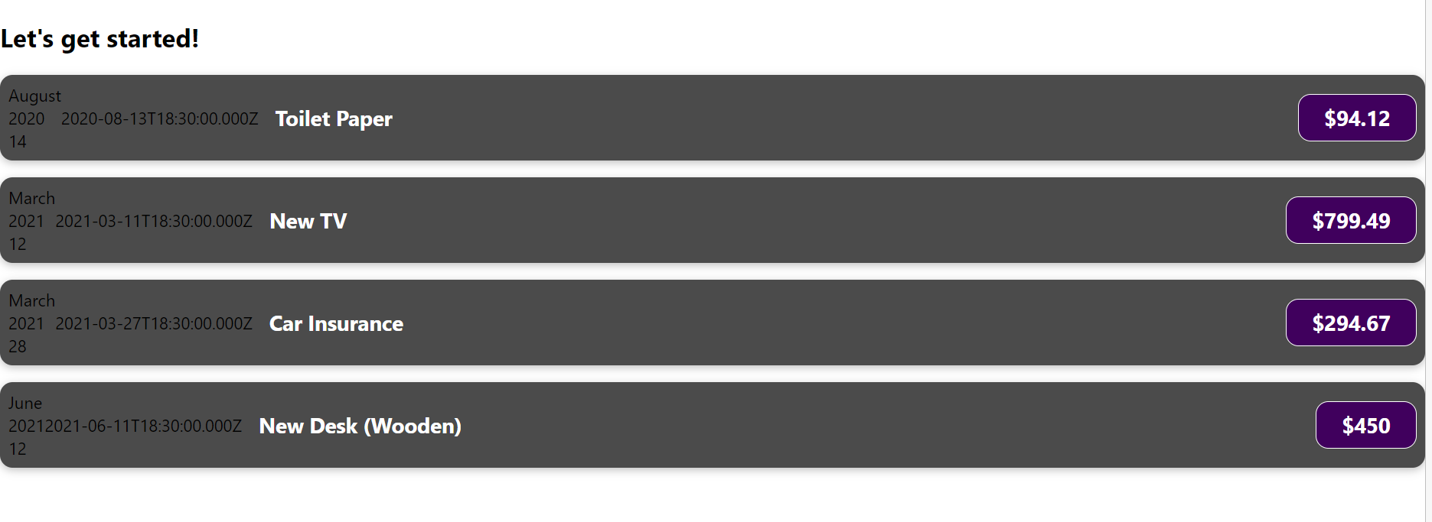

Splitting Components In Multiple components

Add a new File as ExpenseDate.css

.expense-date {

    display: flex;

    flex-direction: column;

    width: 5.5rem;

    height: 5.5rem;

    border: 1px solid #ececec;

    background-color: #2a2a2a;

    color: white;

    border-radius: 12px;

    align-items: center;

    justify-content: center;

  }

  .expense-date__month {

    font-size: 0.75rem;

    font-weight: bold;

  }

  .expense-date__year {

    font-size: 0.75rem;

  }

  .expense-date__day {

    font-size: 1.5rem;

    font-weight: bold;

  }

Add new File ExpenseDate.js

import './ExpenseDate.css';

function ExpenseDate(props) {

  const month = props.date.toLocaleString('en-US', { month: 'long' });

  const day = props.date.toLocaleString('en-US', { day: '2-digit' });

  const year = props.date.getFullYear();

  return (

    <div className="expense-date">

      <div className="expense-date__month">{month}</div>

      <div className="expense-date__year">{year}</div>

      <div className="expense-date__day">{day}</div>

    </div>

  );

}

export default ExpenseDate;

ExpenseItem.js

import './ExpenseItem.css';

import ExpenseDate from './ExpenseDate';

function ExpenseItem(props)

     {

    return (

        <div className='expense-item'>

         <ExpenseDate date={props.date} />

        <div>{props.date.toISOString()}</div>

        <div className='expense-item__description'>

          <h2>{props.title}</h2>

          <div className='expense-item__price'>${props.amount}</div>

        </div>

      </div>

    );

  }

export default ExpenseItem;

output

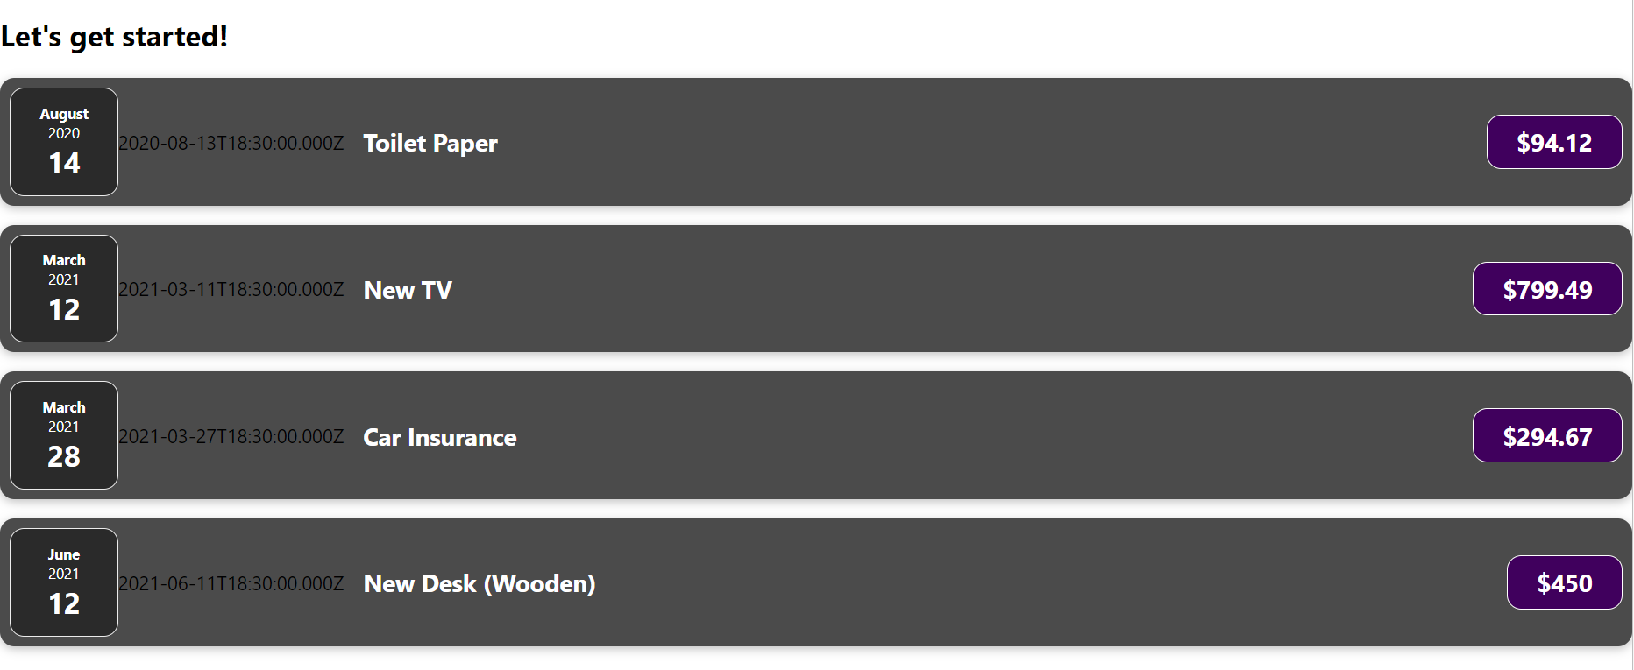

Split Expense in a separate file and Applying uniform style to all components

Add card.js

import './Card.css';

function Card(props) {

  const classes = 'card ' + props.className;

  return <div className={classes}>{props.children}</div>;

}

export default Card;

card. Css

.card {

    border-radius: 12px;

    box-shadow: 0 1px 8px rgba(0, 0, 0, 0.25);

  }

Expenses.js

import ExpenseItem from './ExpenseItem';

import Card from './Card';

import './Expenses.css';

function Expenses(props) {

  return (

    <Card className="expenses">

      <ExpenseItem

        title={props.items[0].title}

        amount={props.items[0].amount}

        date={props.items[0].date}

      />

      <ExpenseItem

        title={props.items[1].title}

        amount={props.items[1].amount}

        date={props.items[1].date}

      />

      <ExpenseItem

        title={props.items[2].title}

        amount={props.items[2].amount}

        date={props.items[2].date}

      />

      <ExpenseItem

        title={props.items[3].title}

        amount={props.items[3].amount}

        date={props.items[3].date}

      />

    </Card>

  );

}

export default Expenses;

Expenses.css

.expenses {

  padding: 1rem;

  background-color: rgb(31, 31, 31);

  margin: 2rem auto;

  width: 50rem;

  max-width: 95%;

}

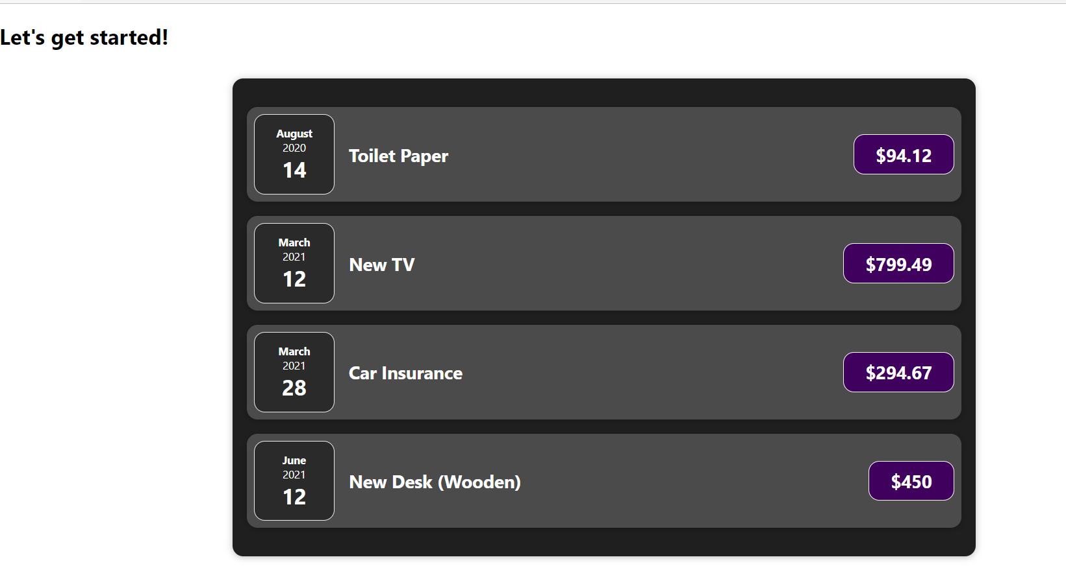

Organizing the components in a proper way

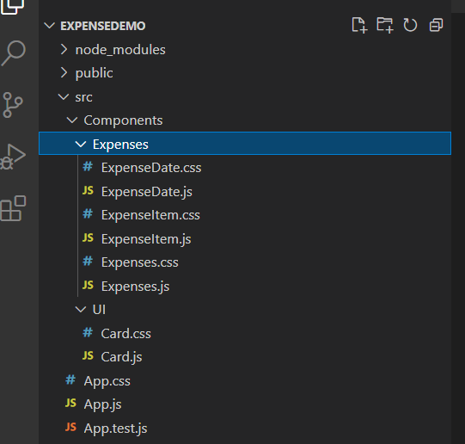

After moving all the files in related folder change the path in every component with th newly created folder path.

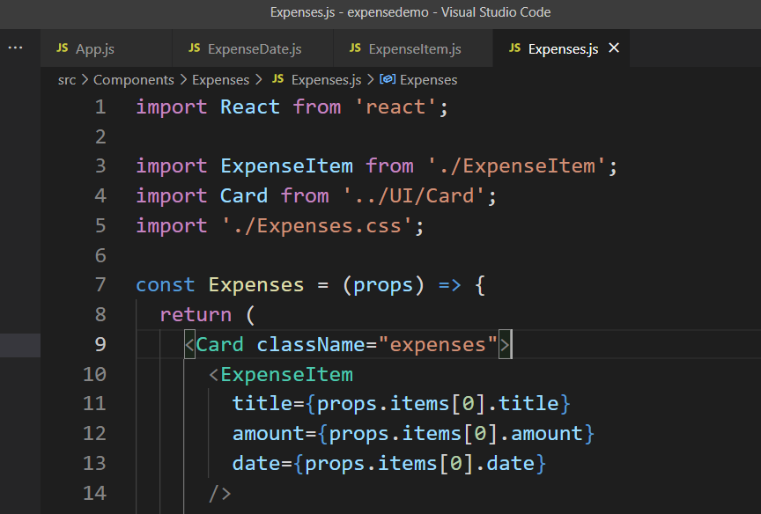

Event Handling

ExpenseItem.js

import React from 'react';

import ExpenseDate from './ExpenseDate';

import Card from '../UI/Card';

import './ExpenseItem.css';

const ExpenseItem = (props) => {

  return (

    <Card className='expense-item'>

      <ExpenseDate date={props.date} />

      <div className='expense-item__description'>

        <h2>{props.title}</h2>

        <div className='expense-item__price'>${props.amount}</div>

        <button onClick={() => {console.log('Clicked')}}>Change Title</button>

      </div>

    </Card>

  );

}

export default ExpenseItem;

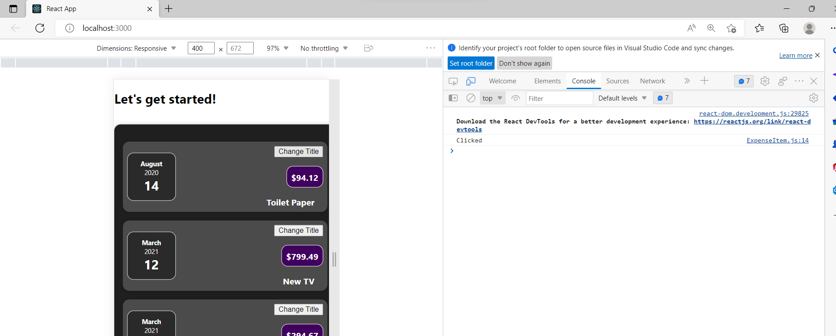

Writing anonymous function in button tag itself is not a good idea. So let us create function and call in click event

import React from 'react';

import ExpenseDate from './ExpenseDate';

import Card from '../UI/Card';

import './ExpenseItem.css';

const ExpenseItem = (props) => {

  function clickHandler()

  {

    console.log('Clicked !!!!!!')

  }

  return (

    <Card className='expense-item'>

      <ExpenseDate date={props.date} />

      <div className='expense-item__description'>

        <h2>{props.title}</h2>

        <div className='expense-item__price'>${props.amount}</div>

        <button onClick={clickHandler}>Change Title</button>

      </div>

    </Card>

  );

}

export default ExpenseItem;

const clickHandler = () =>

  {

    console.log('Clicked !!!!!!')

  }

output

